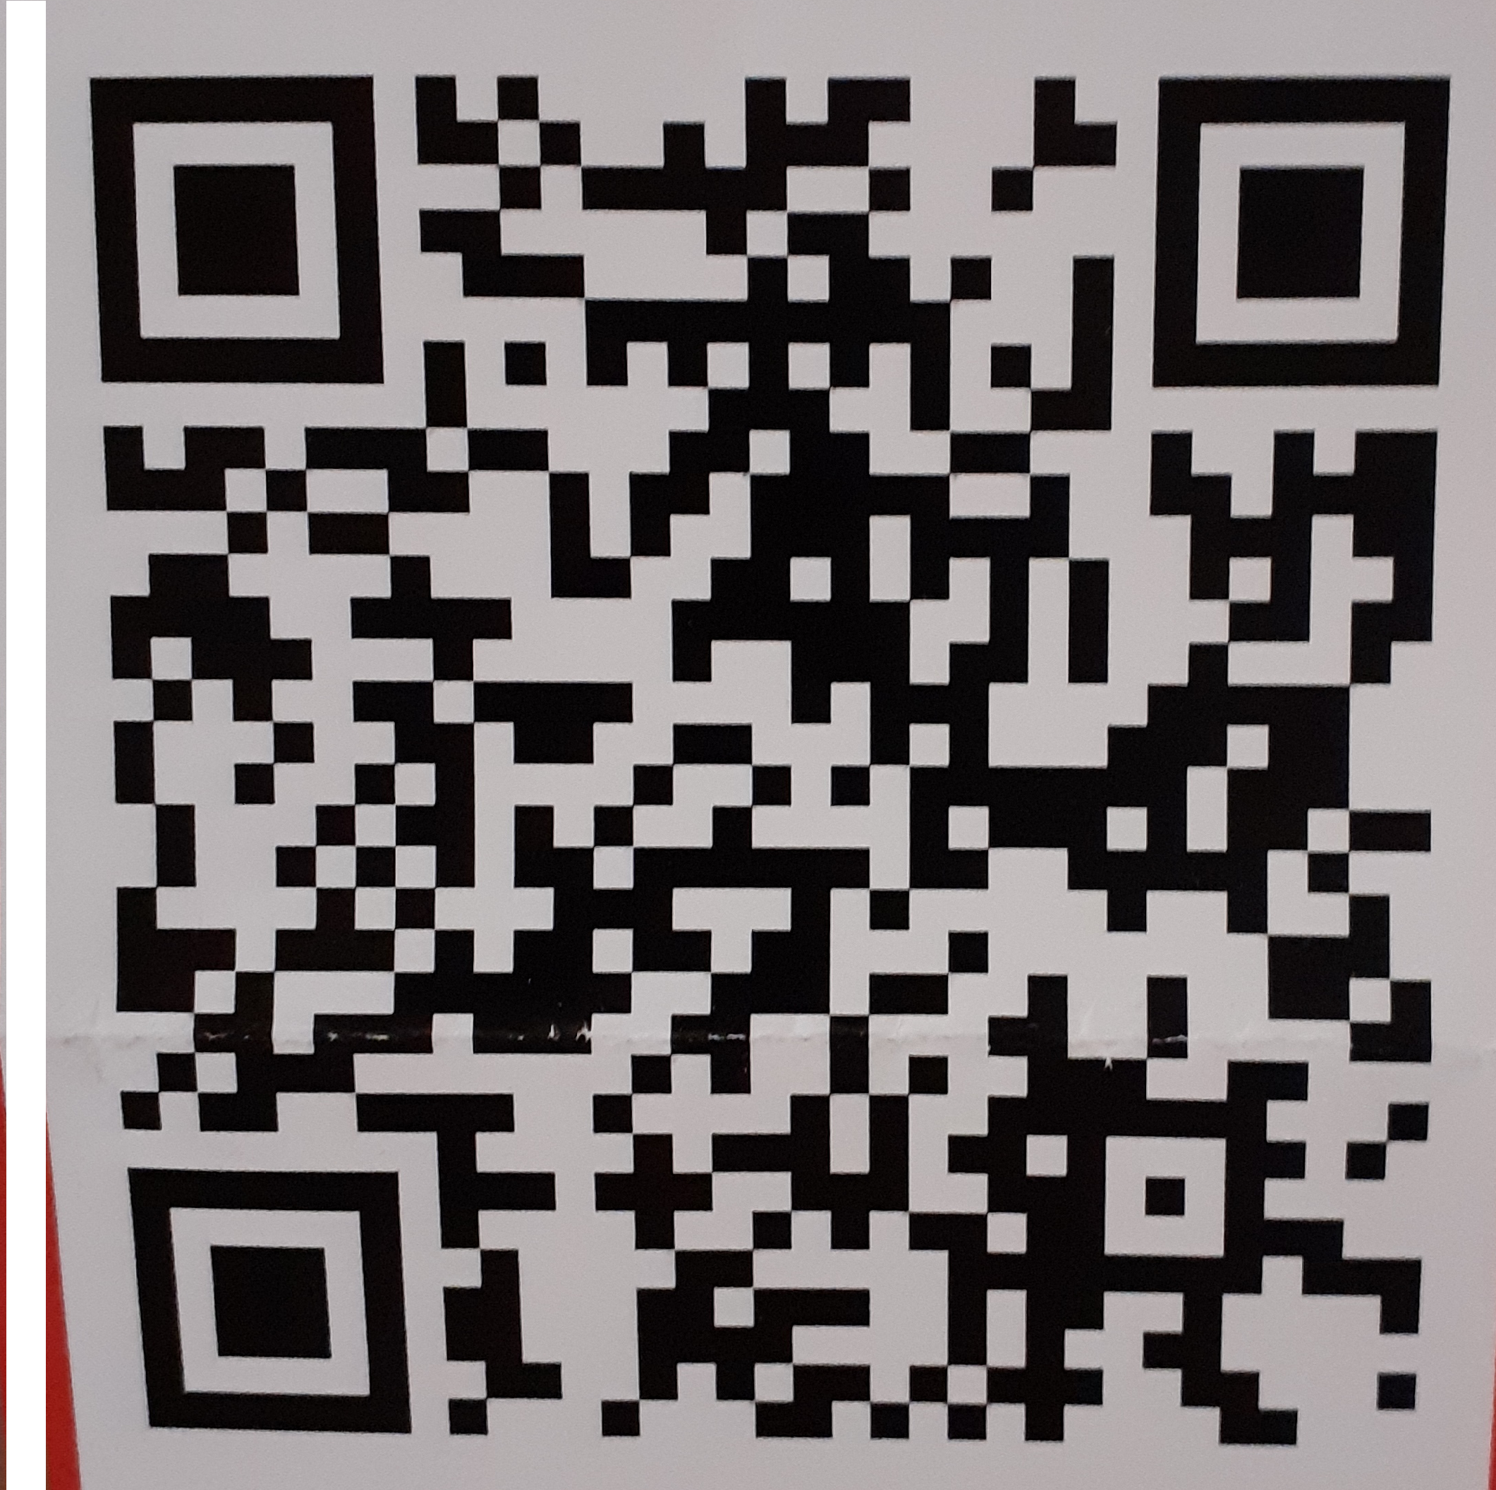

SCRIPTURE REFLECTION
In the spirit, the angel took me to the top of an enormous high mountain and showed me Jerusalem, the holy city coming down from God out of heaven. […] I saw there was no temple in the city. God and Lamb = the temple (Apoc. 21:10-14, 21-23)
In the vision of the last things John recounts a vivid image of the heavenly Jerusalem. There is no temple since the Lord God Almighty and the Lamb are themselves the temple, and the city did not need the sun or the moon for light, since it was lit by the radiant glory of God and the Lamb was a lighted torch for it. Jesus proclaimed himself to be the Light of the World. We are baptised into Christ. We are grafted into the vine – Jesus is the trunk, we are the branches – as one we form light. St. Paul tells us we are temples of the Holy Spirit. Grafted into Christ, let us be guided, illumined and pruned by him that we in turn may guide, illumine and shape others. As we receive the Holy Spirit in the different sacraments, we have potential to grow in faith and love. Lord, fill me with your Holy Spirit.
HOLY FATHER’S PRAYER INTENTIONS FOR MAY We pray for all young people, called to live life to the fullest; may they see in Mary’s life the way to listen, the depth of discernment, the courage that faith generates, and the dedication to service.
POPE FRANCIS INVITES US TO PRAY WITH SCRIPTURE: read a passage, choose a word or phrase; read it again, meditate (active thinking), and contemplate (sit in silence holding the thought). Re-read the text - ask God what he wants me to do … act of charity, change your ways, forgive, help others in their journey, accept help in yours … Sit, listen, pray, act. Try the following text: In the spirit, the angel took me to the top of an enormous high mountain and showed me Jerusalem, the holy city coming down from God out of heaven. […] I saw there was no temple in the city. God and Lamb = the temple (Apoc. 21:10-14, 21-23)
MAY IS THE MONTH OF OUR LADY let’s dedicate it to the sick and housebound and for parishioners preparing to receive the sacraments. Sunday 29th May Annual Procession in honour of Our Lady of Lourdes KT1 4EU. See poster in hall.

PARISH MATTERS AND NEWS FROM THE SONS OF DIVINE PROVIDENCE – CHURCH HALL OPEN FOR MASSES
CHURCH HALL OPEN FOR MASS The hall has been reorganized for Sunday and weekday Masses to accomodate 70 persons including children. Our church building remains closed pending structural investigations and repair planning. More updates via Sacred Heart parish and school websites, word of mouth and notices on church doors. Something is beginning to stir in the direction towards initiating a proactive response that will lead to repair works beginning. Please pray for a speedy outcome.
SUPPORT FOR UKRAINE Sons of Divine Providence and Don Orione Orione Sisters are actively present in Ukraine. They are staying to support the local people, including disabled persons in Lviv and Korotycz near Kharkiv. See Don Orione Ukraine on Google. To donate: Bank transfer reference: “Ukraine Emergency” Payee: Don Orione Onlus Foundation To: INTESA Sanpaolo Spa, Milano; IBAN: IT57 S030 6909 6061 0000 0001 484; BIC / SWIFT CODE: BCITITMMXXX Thank you.
New to the parish? We are so happy to Welcome you! Email teddington@rcdow.org.uk or ask for a form to register your details.
Mass Intentions – envelopes now available on the trolley in the hall.
Parish communications - knock the door. If no answer, leave a message, telephone or send an email. We’ll get back to you.
Parish Safeguarding Representative Estella Weston, email: teddingtonsg@safeguardrcdow.org.uk More PSRs welcome!
Contacting Traci, our bookkeeper email teddingtonbk@rcdow.org.uk or ring the Parish Office on 020 8977 2986 between 1.30-4.30pm on Thursdays with questions regarding donations, gift aid or parish finances.

Parish finances - our grateful thanks to all parishioners who continue to support the parish financially. April: S.O. £2,105.00; Loose plate and Contactless £0. Last Sunday loose plate collection £99.22; Dona £14.00 To donate for Sunday collection, use QR code shown here – use the photo setting of your mobile phone.
To set up a Standing Order: Forms available. Pay at HSBC Bank plc. Account no. 21094548 Sort Code 40-05-20 credit of WRCDT Teddington (& Hampton Wick); Please give your initials and surname so we may identify payments. Further info - Traci as above.
Building Works will potentially create a massive drain in our finances. Hopefully costs can be shared to lessen the blow. The finance committee are being updated as things progress The Archdiocese are being as supportive as possible. We await reports and decisions regarding scaffolding for roof and ceiling repairs. Things are becoming clearer and we hope soon to have news of arrival of scaffolding for the roof repairs, Further drain investigations imminent. Scaffold within the church hopefully coming soon. There is an urgency as there is more lathe and plaster that could fall at any time.

22nd May 2022 FIFTH SUNDAY OF EASTER Psalter Week III
SDP GENERAL CHAPTER starts 31st May in Italy. Please pray for the participants and for the Don Orione activities worldwide.
SACRAMENTS – To register email the parish office - remember you must give at least six months’ notice for marriage here in the UK, and more for overseas. Pray for candidates and catechists please. Next Baptismal course for parents and sponsors Monday 20th June at 7.00pm – sign up now. Anyone wishing to come on board as catechist – please let us know. Training available. Congratulations Declan, Anastasia & Lucas now confirmed. And to Michael & Amy, Maria & Tom soon to be married.
VOLUNTEERS NEEDED at Sacred Heart Church - trained First Aiders; Fire safety wardens to be available in case of emergency during Masses; a Parish Safeguarding Representative (PSR) for 11.15 Mass or to alternate 9.30am / 11.15am; Parish Committee members; youth animator – training available. Volunteers to attend the parish house when necessary.
SYNODAL PATHWAY 2021-23 For a Synodal Church – see Diocese of Westminster Bishops Report – on-line. A CHALLENGE let’s read the report and then meet together as Sacred Heart parishioners and ask how we can progress as MISSION / charitable works?

BEYOND OUR PARISH
AID TO THE CHURCH IN NEED www.acnuk.org CARITAS UKRAINE https://www.csan.org.uk/ukraine/ CARITAS VOLUNTEER SERVICE www.caritasvs.org.uk; PENTECOST CHALLENGE www.friendsoftheholyland.org.uk/pentecost22
CATHOLIC LISTENERS A new confidential listening helpline, set up for those who are returning to the faith. This is not a counselling service, but has a professional team trained on signposting to other services and agencies, aiming to help those in need of a safe space to talk. For further information please contact Ade at Catholiclisteners@gmail.com or call 0800 448 0704.
CHRISTIAN LEADERSHIP FORMATION PROGRAMME running for a second consecutive year and currently open to applications from students in Lower VI. The application deadline is Friday 3rd June 2022, although references will still be accepted after that date for applications already submitted. The programme is for students who are actively committed to their faith, who are intellectually gifted and who are committed to shaping a Christian society through their careers. Part- to full sponsorships are available to students who are unable to meet the costs, though students are asked to attempt to fundraise £140 (10% of the course’s costs) as a minimum contribution. Information and application forms are available here: https://christianheritagecentre.com/clf/.
ANNUAL PILGRIMAGE TO LOURDES led by Cardinal Vincent Nichols 22nd – 29th July. See notice board in hall.
MISSIO Today (Sunday) is a day of prayer and celebration for the overseas mission organisation ‘Missio’, as one of its founders, Pauline Marie Jaricot, will be beatified in Lyon. It’s a leap forward on the path to Sainthood that will see Pauline Jaricot declared a ‘Blessed’. Check it out on MISSIO or Archdiocese of Westminster website
CROSSLIGHT ADVICE ON DEBT, BUDGETING AND MONEY MANAGEMENT Financial worries can be an enormous strain. Our local branch of Crosslight is based in the Crossway Centre at St Stephen’s church in Twickenham and offers appointments on Thursdays where you can receive advice and support about your money from experienced advisors or take a short course to build your budgeting skills. Call 020 7052 0318, email info@crosslightadvice.org or see www.crosslightadvice.org.
VACANCIES AT ST RICHARD REYNOLDS SCHOOL Primary School Teacher, and teachers of Religious Education and Design Technology. Please see strichardreynolds.org.uk/our-college/vacancies for further details – application deadline tomorrow!
ST ANTHONY COMMUNICATIONS CONFERENCE 2022, Saturday 4th June, St Mary's West Croydon, with guest speakers Dr Ralph Martin, Fr Marcus Holden, and Fr Andrew Pinsent. Cost £22. Book by calling 01834 812643 or see www.saintant.com.
CAFOD - the paradox of abundance Over 800 million people go hungry each day. Yet the world produces over 4 billion tonnes of food and we only need 3.7 billion tonnes to feed everyone. From all this food produced, a third is wasted. St John Paul II called this ‘the paradox of abundance.’ Clearly the currently global food system is not working. But as Pope Francis said, "Each of us has a role to play in transforming food systems for the benefit of people and the planet." Let’s respond to his call! CAFOD’s new campaign is called Fix the Food System. See www.cafod.org.uk/food for more information, including an invitation for parish groups to learn about the impact of our food with our Fix the Food System: a 7-station journey resource.
DEVOTIONS www.divinemercyapostolate.co.uk First Friday/Saturday & Annual Pilgrimage to Walsingham. See posters in hall.

PARISH INFORMATION
Fr Stephen Beale FDP, Parochial Administrator (for Fr. Reg Dunkling)
Email: teddington@rcdow.org.uk
Telephone: 020 8977 2986
Mass times: 9.30am and 11.15am in parish rooms until roof repairs are complete. Other local Sunday Masses: 9.30am (in English) and 10.00 and 11.15am (in Polish) at Sons of Divine Providence, Hampton Wick

NEXT WEEK’S READINGS
(29th May, Seventh Sunday of Easter, Year C)
Acts 7:55-60; Apoc 22:12-14, 16-17,20;
John 17:20-26

Weekday Masses
Sunday | 22nd May | Sixth Sunday of Easter | 9.30am  11.15am | Parishioners  MCJA staff
Monday | 23rd May | Sixth Monday of Easter | 9.30am | Bob Allen RIP anniv.
Tuesday | 24th May | Sixth Tuesday of Easter | 9.30am | Jessie Simpson RIP
Wednesday | 25th May | St Gregory VII, Pope; St Mary Magdalen de Pazzi; St Bede the Venerable | 9.30am | Don and Agnes Campbell RIP
Thursday | 26th May | ASCENSION OF THE LORD | 09.30/8pm | Mary & Jack Fedigan RIP / For the church
Friday | 27th May | St Augustine of Canterbury | 9.30am | Special intention
Saturday | 28th May | Sixth Saturday of Easter | No Mass | Mass in Cathedral for Clergy RIP (covid)
Sunday | 29th May | Seventh Sunday of Easter | 9.30am  11.15am | Alvin Fabila Snr RIP  Parishioners

